Tutorial 10
Tasks:
- Develop your own data through labelling
- Use the data you developed and test it on the model developed and change the layers.
- Use different learning rates and visualize the results

The goal of this project was to implement a U-Net deep learning model from scratch to perform image segmentation on a custom guns dataset. The model was trained to predict pixel-level masks that identify the exact shape and location of weapons in images, going beyond simple bounding box detection.
Dataset
The dataset was created and labeled using the Roboflow platform. It is an instance segmentation dataset, where objects are labeled using the polygon tool to capture their exact shape.
The dataset is in COCO segmentation format and contains one class, Guns, including different types such as rifles, submachine guns, and swords. It is divided into training, validation, and test sets.
Initially, the dataset was labeled for object detection using bounding boxes. Later, it was recreated as a segmentation dataset and re-labeled using polygons to generate accurate masks for training.
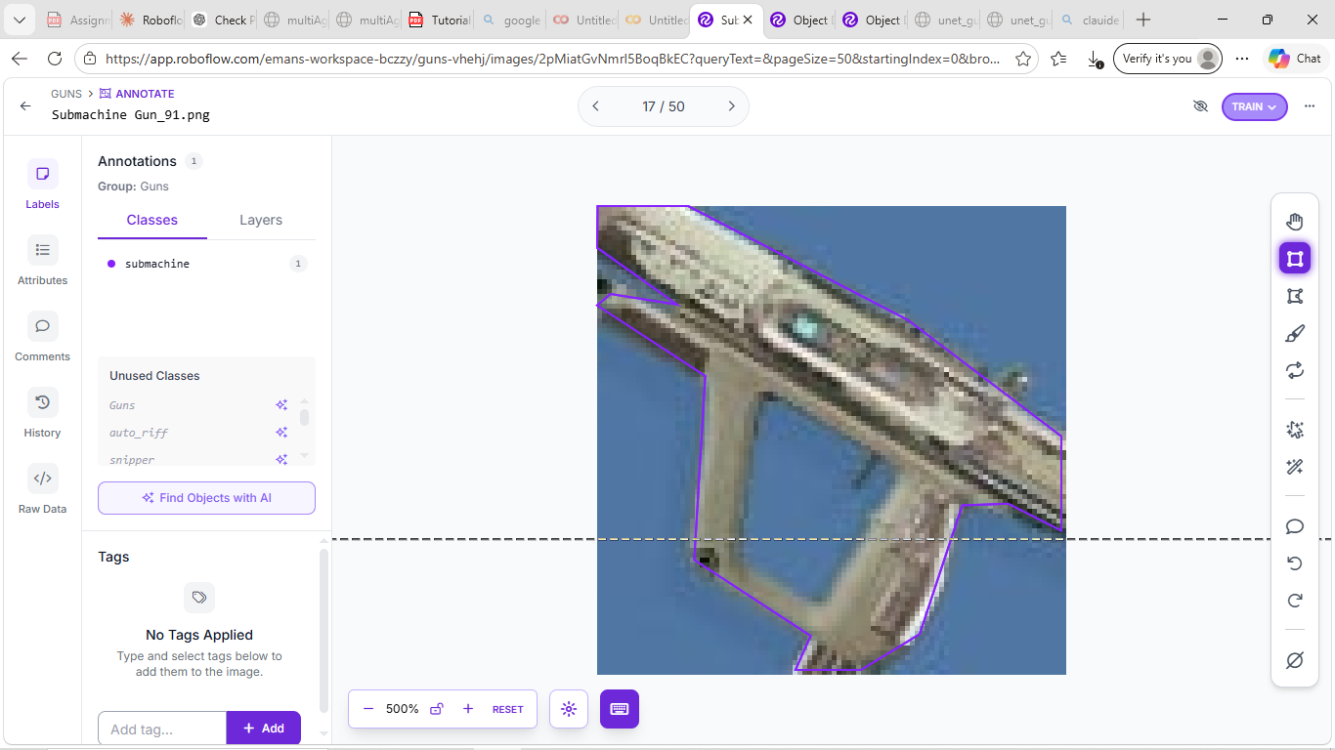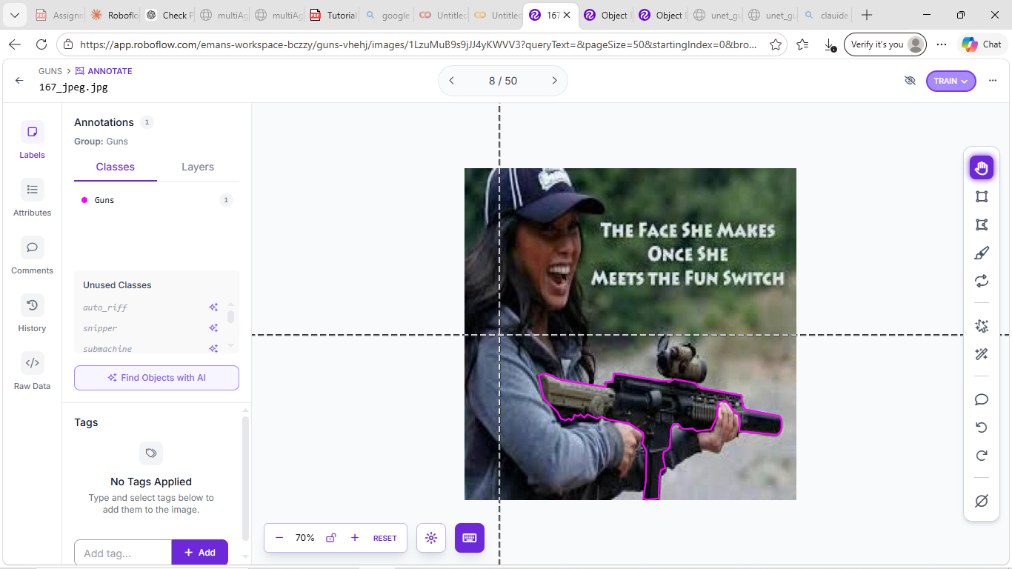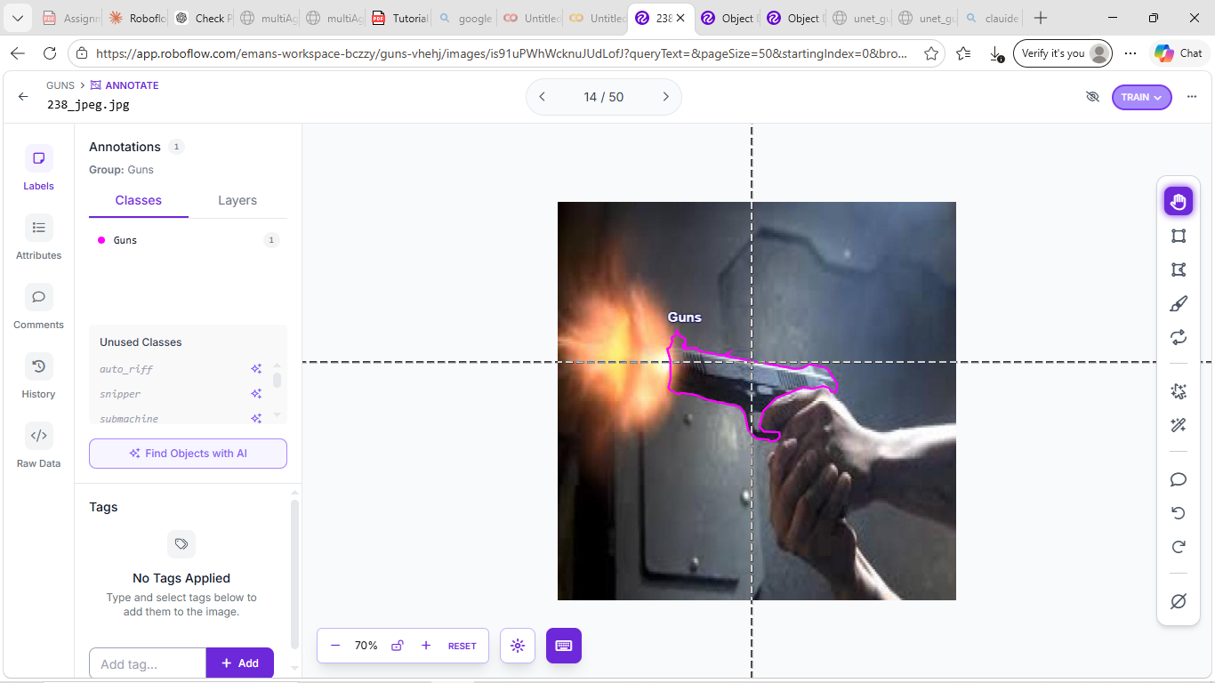

Results and Discussion
- Baseline Model
In the first version, a simple U-Net model was used with a smaller image size (128×128) and only two encoder levels. The model was trained for 10 epochs using BCE (Binary Cross Entropy) loss.
BCE loss works by checking each pixel individually and comparing the predicted value (gun or background) with the actual value. It tells the model how wrong each pixel prediction is.
However, BCE alone is not very effective for segmentation because it treats all pixels equally. Since most pixels in an image are background, the model focuses more on background and does not learn the exact shape of the gun properly.
As a result, the model could only detect rough shapes and missed fine details. The mean IoU was around 0.70. the model is not accurate enough as shown

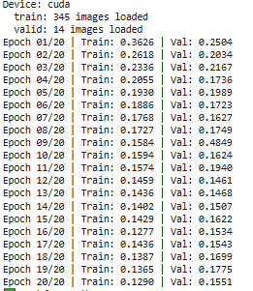
- Training loss spikes were mainly caused by small dataset size, batch variation, and early training instability, and they reduced in later versions as training became more stable.
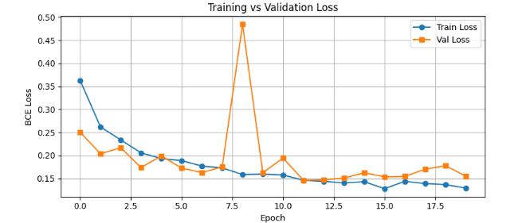
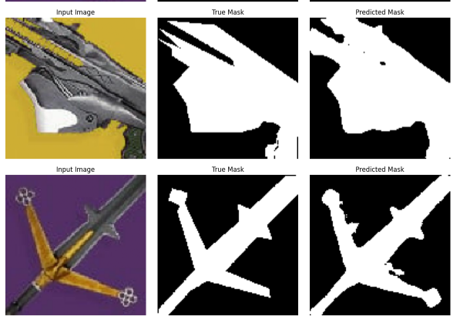
- Improved Model
In Version 2, several improvements were made. The image size was increased from 128 to 256 to capture more details, and the U-Net depth was increased to learn more complex features. The loss function was changed from BCE to BCE plus Dice, where BCE handles pixel accuracy and Dice improves mask overlap. Also the epochs increases from 10 to 50.
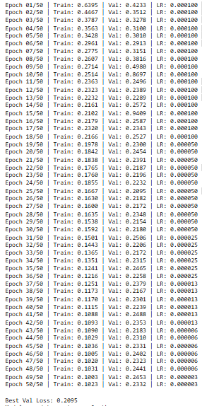
A learning rate scheduler was also added to reduce the learning rate during training, making the process more stable. The model was set to save the best-performing epoch instead of only the final one.
During training, the loss decreased steadily (from 0.63 to around 0.10), showing good learning. The best validation loss achieved was 0.2095. Some spikes were observed in validation loss, mainly due to the small dataset and difficult samples, but this is normal.
The results shows significant improvement over Version 1, with better accuracy and mask quality, but slight instability remains.
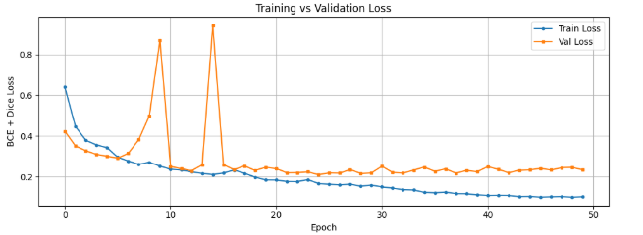
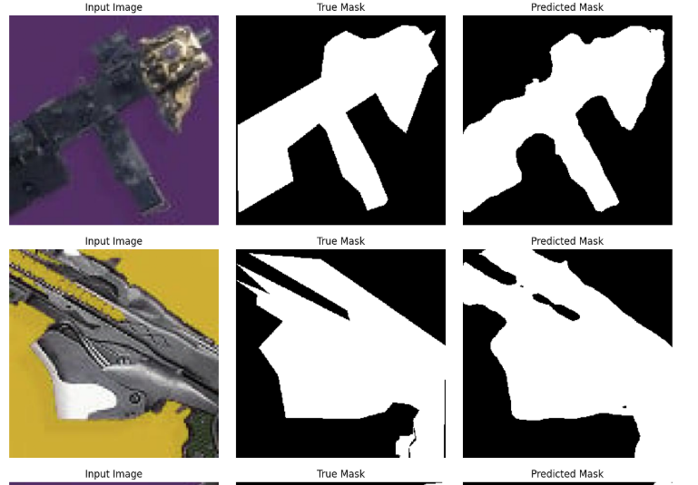

- Stable Training
In Version 3, training was improved using a cosine learning rate scheduler, gradient clipping and weight decay to make learning more stable and reduce overfitting. The number of epochs also increased from 50 to 60.
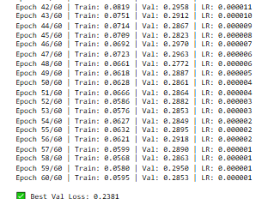
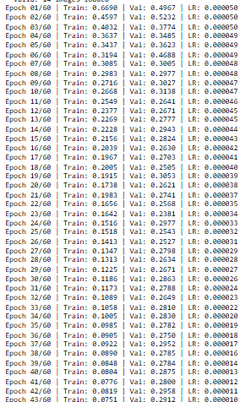

The model achieved strong results, with training loss decreasing to around 0.05 and best validation loss of 0.2381. Training became smoother compared to previous versions, but a gap between training and validation loss was still observed, indicating overfitting.
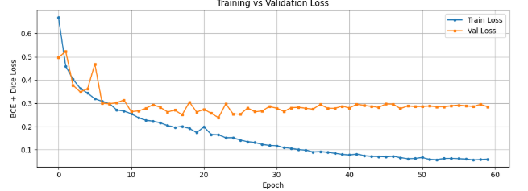
The results shows best accuracy so far, but slight overfitting remains.
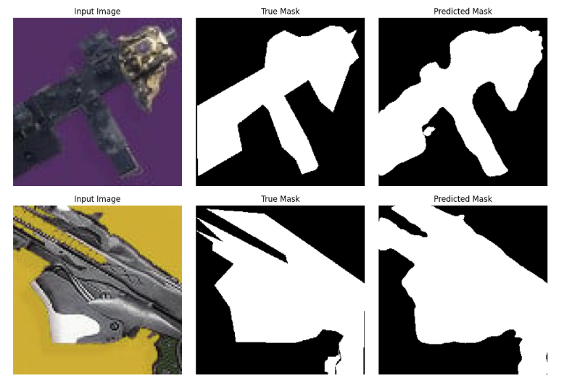

The IoU was also calculated to know better understanding of results. The Mean IoU (0.8841) shows that the model performs well overall in segmenting gun objects. The Best IoU (0.9543) indicates almost perfect prediction on some easy images with clear shapes and backgrounds. The Worst IoU (0.7716) shows that even in difficult cases, the model still captures most of the object but with some small errors.
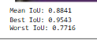
- Final Model (With Augmentation)
In Version 4, data augmentation (flips, rotation, brightness, zoom) was added to improve generalization and reduce overfitting.
As a result, the train loss (0.19) and validation loss (0.27) became closer, showing better balance between learning and generalization. Overfitting was significantly reduced compared to previous versions.
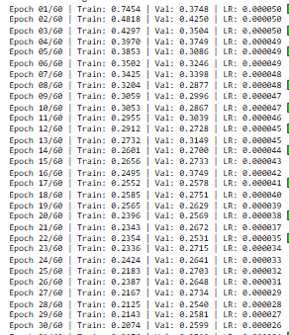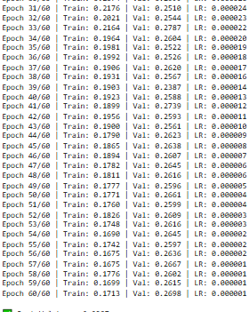
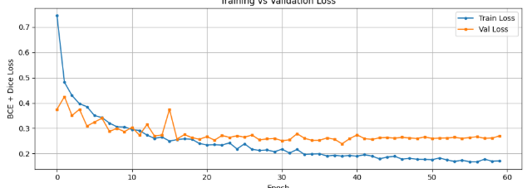
The model also became more consistent, with worst IoU improving from 0.7116 to 0.7772, while maintaining a strong mean IoU of 0.8722 and best IoU of 0.9332. However, thin and complex objects like trace rifles were still slightly difficult to segment.
This model performs best overall from all previous models.
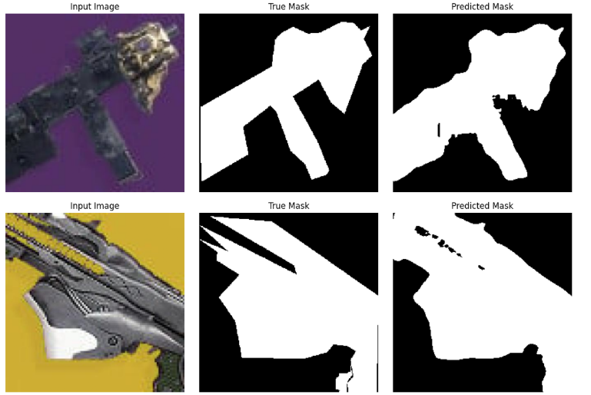

Conclusion
This project implemented U-Net from scratch for weapon segmentation and improved it through four versions, reaching a final Mean IoU of 0.8722 with reduced overfitting.
Key lessons learned were that polygon labeling is essential for segmentation, BCE + Dice loss performs better than BCE alone, data augmentation reduces overfitting, and proper scheduling and training techniques improve stability.
Model 1 gave basic results due to low resolution and simple loss. Model 2 improved accuracy by increasing image size and adding Dice loss. Model 3 achieved the best accuracy but showed overfitting. Model 4 became the best overall model by improving generalization using data augmentation.
Overall, the final model is the most balanced and performs well on unseen data.

